# Module 1

**Tensors and Datasets**

**Tensors 1D**

## 📌 Overview of Tensors

Tensors are the foundational data structures used to construct and operate neural networks in PyTorch.

A neural network is fundamentally a mathematical function that accepts one or multiple inputs, processes them, and returns one or more outputs.

In PyTorch, this processing is performed using **tensor operations**, which are generalized versions of familiar mathematical operations like addition and multiplication.

### 🔹 Tensors as Building Blocks

PyTorch tensors serve as the unified representation for **inputs**, **outputs**, and **parameters** within a neural network. These tensors can represent vectors, matrices, or higher-dimensional data structures, depending on the application.

Tensor operations in PyTorch form the computational backbone of how data is manipulated and learned from in neural networks.

PyTorch tensors are a generalized form of **numbers and dimensional arrays** in Python.

* 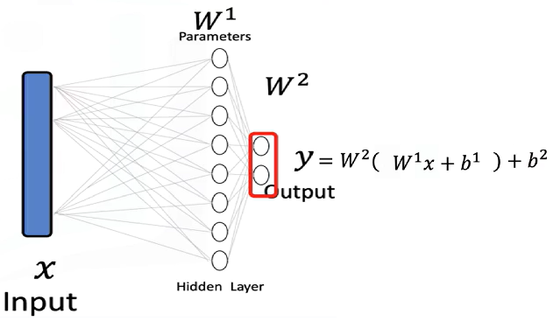The **input x** to a neural network is a tensor.
* The **output y** is also a tensor.
* The **parameters** of the model are tensors as well.
* Tensor operations allow the neural network to **transform inputs** into outputs during training and inference.

Neural networks use these tensor operations to apply **mathematical transformations**, often in the form of **vector and matrix operations**. These operations simulate the way real-world data is processed and are used throughout the course as the standard method for feeding data into neural models.

### 🔹 Examples of Tensors in Neural Networks

**Databases** can be treated as a series of tensors, where each row represents an input tensor (x) in a neural network.

A tensor is simply just a vector or a rectangular array consisting of numbers.

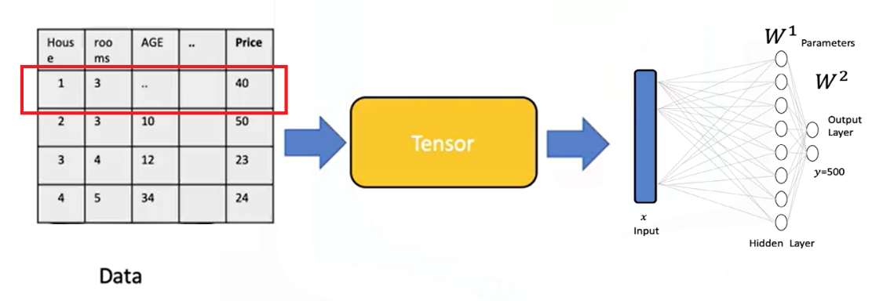

**Images** can be converted into 2D or 3D PyTorch tensors and used as input for classification tasks.

* + Each tensor of the input is simply a matrix or rectangular array.
  + Images are typically stored as arrays.
  + Neural networks can receive these as tensors and perform classification based on the processed values.
  + For instance, an image can be transformed into a tensor and classified as the digit **zero**.

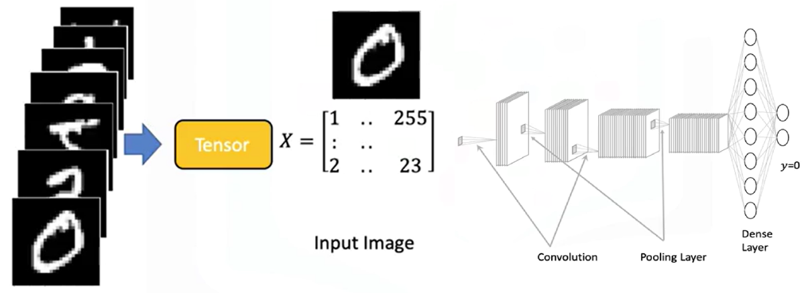

### 🔹 Tensor Conversion and Compatibility

PyTorch tensors can be easily **converted to NumPy arrays**, and NumPy arrays can also be converted into PyTorch tensors.

This bidirectional conversion enables seamless operation within the **Python ecosystem** and allows integration with many existing Python libraries.

PyTorch also supports **GPU acceleration**, which is crucial for training large neural networks efficiently.

### 🔹 Parameters and Derivatives in PyTorch

**Parameters** in neural networks are specialized tensors that allow for the calculation of **gradients and derivatives**.

These gradients are essential for learning during training.

To enable gradient tracking, PyTorch tensors must be created with **requires_grad=True**.

This setting allows PyTorch to automatically compute derivatives during backpropagation.

### 🔹 Dataset Class in PyTorch

PyTorch provides a **Dataset class** that simplifies working with large datasets.

Using this class enables efficient data handling, transformation, and loading.

It is especially useful when building neural networks that require batch processing or data augmentation.

### ✅ Takeaways

✅ PyTorch tensors are the core data structures used in building and training neural networks.

✅ Inputs, outputs, and model parameters are all represented as tensors.

✅ Tensor operations in PyTorch generalize familiar mathematical operations and are essential for transforming input data.

✅ Databases and images can be represented as tensors and processed within neural networks.

✅ PyTorch integrates seamlessly with NumPy and supports GPU acceleration for scalable training.

✅ Setting requires_grad=True enables tensors to compute gradients, allowing for neural network training.

✅ The Dataset class simplifies data management and is essential for working with large-scale training data.

## 📌 Tensors 1D

### 🔹 Understanding 1D Tensors

* A **0D tensor** represents a single number.
* A **1D tensor** is an array of numbers and can represent:
* A row in a dataset
* A vector
* A time series
* A tensor contains elements of a **single data type**, there is a variety of different tensor types depending the data type of the elements in the tensor, such as:
* float or double tensors (for real numbers)
* byte tensors (for 8-bit images and unsigned integers)

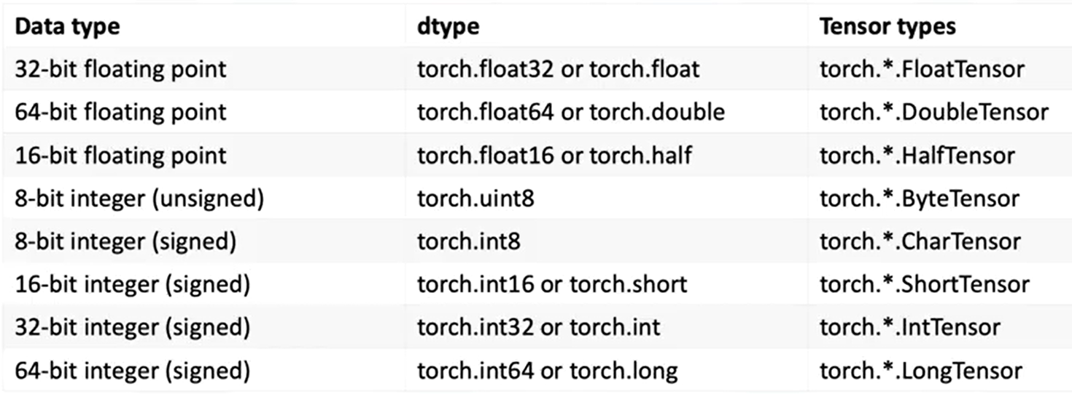

### 🔹 1D Tensor Operations

🔸 **Creating a tensor:**

* + Use **torch.tensor()** to convert the list into a tensor.
  + Data can be accessed via index.

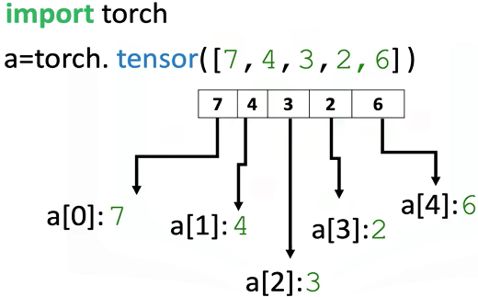

🔸 **Tensor Type and Data Type:**

* + Use the **.dtype** attribute to identify the data type stored in a tensor.
  + Use **.type()** to identify the tensor type.

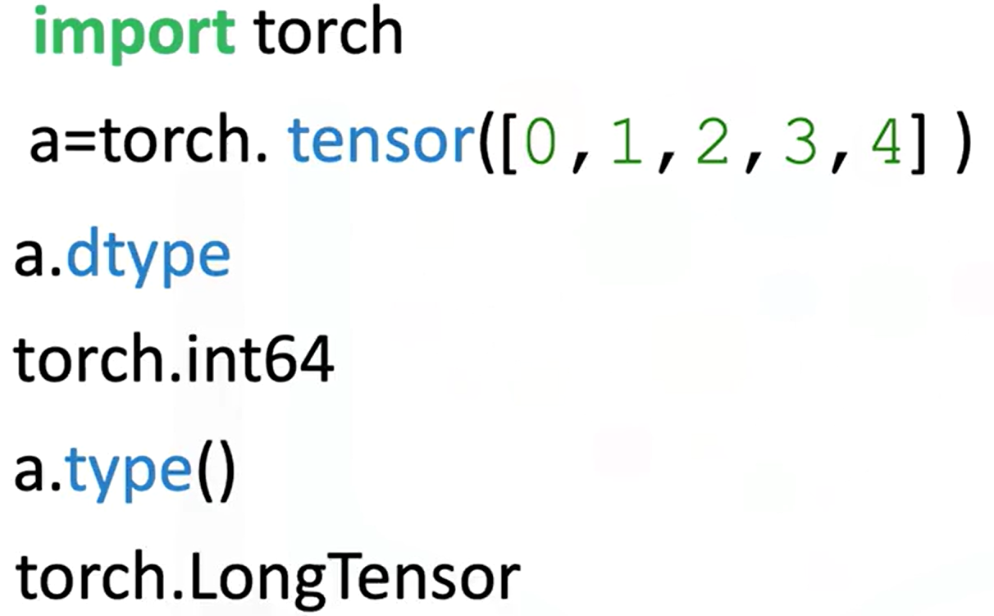

* + Explicitly set the data type using the **dtype** parameter.



* + Using classes like **torch.FloatTensor**.

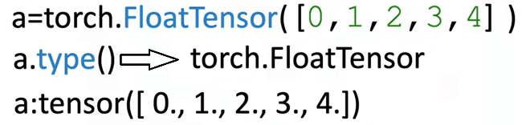

* + Use **.type(torch.FloatTensor)** to convert to a float tensor.

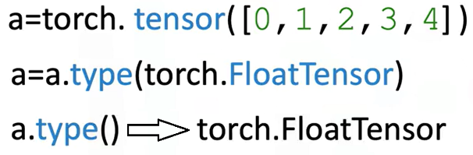

🔸 **Tensor Size and Shape:**

* + Use **.size()** to find the number of elements.
  + Use **.ndimension()** to find the number of dimensions (tensor rank).

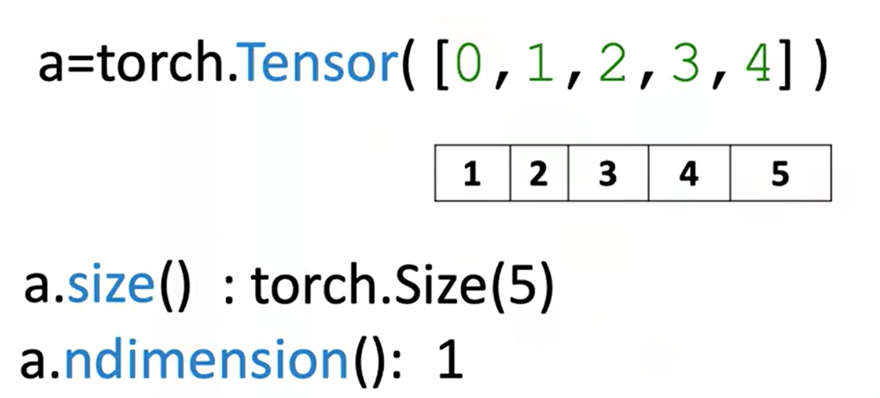

* + 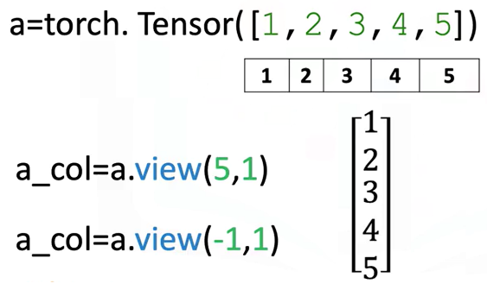Convert a 1D tensor to 2D using **.view(number_rows, number_cols)**:
* **view(5, 1)** turns a 1D tensor with 5 elements into a 2D column tensor.
* Use **view(-1,1)** to let PyTorch infer dimensions.

🔸 **Tensor Conversion with NumPy and Pandas**

* + Convert a NumPy array to a tensor with **torch.from_numpy()**
  + Convert a tensor to a NumPy array using **.numpy()**

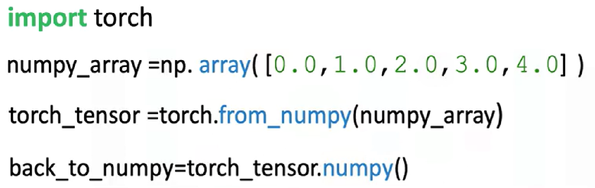

**⚠️ Memory sharing:**

Modifying the original NumPy array affects the PyTorch tensor and vice versa.

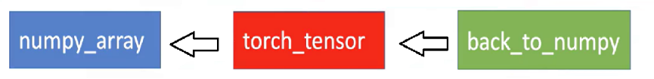

* + Convert Pandas series to tensor:
* Use **.values** to get the NumPy array
* Then apply **torch.from_numpy()**

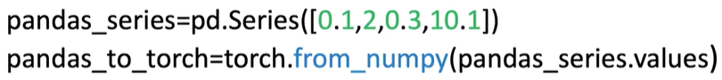

* + Convert tensor to list:
* Use **.tolist()** to get a Python list

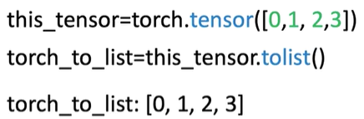

* + Convert tensor element to number:
* Use **.item()** to extract a Python number from a single-element tensor

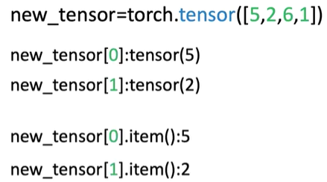

🔸 **Indexing and Slicing:**

## 📌 Q-Learning with Keras

Q-learning is a foundational reinforcement learning algorithm that focuses on training agents to make sequential decisions by maximizing cumulative rewards.

### 🔹 Understanding Q-Learning

Reinforcement learning is defined as a powerful paradigm in machine learning focused on training agents to make **sequences of decisions** by maximizing a **cumulative reward**.

Q-learning is a **value-based** and **off-policy** reinforcement learning algorithm:

* **Off-policy:** It learns the optimal policy independently of the agent’s current behavior
* **Value-based:** The agent learns to estimate the **value** of states or state-action pairs, which represent the expected cumulative reward. These values guide the agent in selecting actions that maximize long-term rewards.

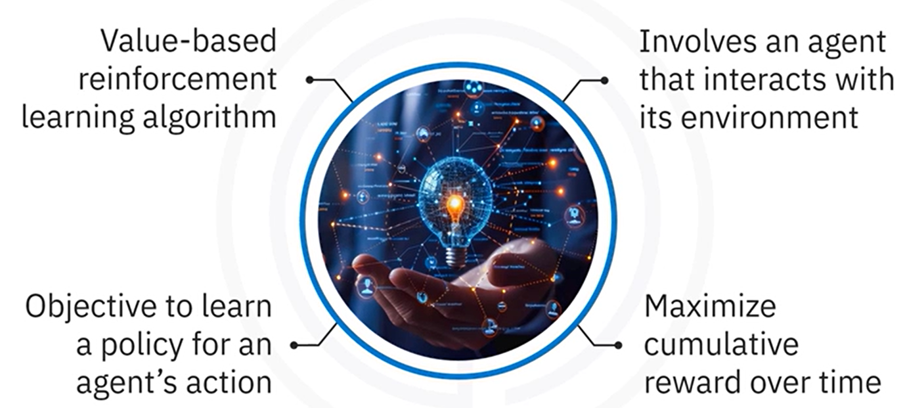

**Q-Learning objective:**

**Learn a policy** that tells the agent what action to take under which state to **maximize cumulative future rewards**.

### 🔹 Q-Value Function and Bellman Equation

Q-learning relies on the **Q-value function**, denoted as $Q(s, a),$ which measures the **expected utility** of taking **action** “**a**” in **state** “**s**”, and then following the **optimal policy** afterward.

The Q-values are updated **iteratively** using the **Bellman equation**, which incorporates:

* The **immediate reward**
* The **estimated future rewards**

The updated rule for Q-value is given by the **Bellman Equation**:

$$Q\left(s,a\right) ←Q\left(s,a\right)+α [ r+ γ \max_{a^{'}} Q\left(s^{'}, a^{'}\right)-Q\left(s,a\right) ]$$

* **s** 🡪 Current state
* **a** 🡪 Current action
* **r** 🡪 Reward received after taking action a
* **s'** 🡪 Resulting state from taking action a
* **a'** 🡪Next action
* **α** (alpha) 🡪 **Learning rate**, controlling how much new information overrides old knowledge
* **γ** (gamma) 🡪 **Discount factor**, determining the importance of future rewards

### 🔹 Q-learning implementation steps

Q-learning implementation consists of **multiple steps** that are essential for allowing the agent to learn and perform effectively:

🔸 **Initialize the environment and parameters:**

Define the environment, using a platform like **OpenAI Gym**

Initialize the **Q-table** with state-action pairs.

Set hyperparameters:

* Learning rate α
* Discount factor γ
* Exploration rate ε

🔸 **Build the Q-network:**

Storing Q-table is infeasible when the state space is large or continuous.

To handle complex environments, we can use a **neural network** function approximator to learn the Q-value function – this approach is known as a **Deep Q-Network (DQN)**.

Instead of a Q-table, a DQN uses a neural network (called the **Q-network**) to **predict Q(s,a)** for any given **state** “**s**” and **action** “**a**”.

This allows Q-learning to scale to high-dimensional or continuous state spaces by leveraging function approximation

* Use Keras to construct a Q-Network that approximates the Q-value function.
* The Q-network replaces the Q-table for large or continuous state spaces.

🔸 **Train the Q-network:**

Training the Q-network involves letting the agent interact with the environment repeatedly and updating the network’s weights based on the Q-learning rule.

We typically train over many **episodes**. In each episode, the agent starts in an initial state from the environment and then proceeds through a sequence of time-steps until the episode ends (for instance, when a termination condition like a pole falling or time limit is reached).

**Training loop** implementation should be as follows:

* The agent interacts with the environment.
* Selects actions.
* Receives rewards.
* Transitions to new states.
* Updates Q-values using the Bellman equation.

🔸 **Evaluate the agent:**

After training the Q-network, we need to **evaluate the agent** to see how well it has learned to solve the task.

Evaluation is typically done by deploying the agent in the environment **without** any exploratory randomness. In this phase, the agent uses the learned Q-network to select the action with the highest Q-value at each state, reliably exploiting its training.

Trained agent is tested in the environment, to assess:

* Overall performance.
* Ability to maximize rewards.

### 🔹 Q-learning implementation with Keras

🔸 **Initialize the environment and parameters:**

The environment which the agent will interact, is from **OpenAI Gym**, **CartPole**.

CartPole is a classic control problem where the objective is to **balance a pole on a moving cart**.

The setup includes:

* Initilizing the Q-table with state-action pairs.
* Defining important parameters that directly influence learning quality and overall agent performance:
* Learning rate α
* Discount factor γ
* Exploration rate ε

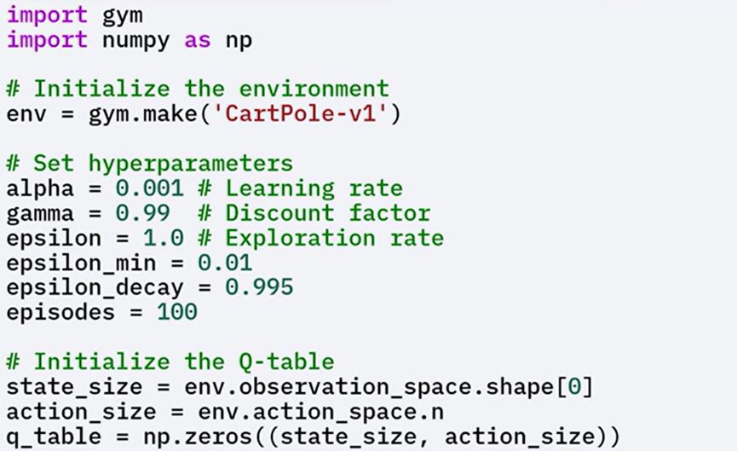The exploration rate Epsilon is initialized to 1.0 and decays over time to shift the agent's behavior from exploration to exploitation.

The state size and action size are determined based on the environment's observation and action spaces respectively.

A Q-table is initialized with zeros, although it is not used directly in the neural network approach.

Since Q-Tables are impractical in environments with **large or continuous** state spaces, a **Q-network** is used to approximate the Q-value function.

🔸 **Build the Q-network:**

By using Keras, Q-Network can be build using a few dense layers:

* The **Input layer size** should match the **state size**.
* The **output layer size** should match the **action size** (number of possible actions), with **linear activation** function
* **Hidden layers** can have any architecture, but **typically two or three hidden layers**, with **ReLu activation** function.

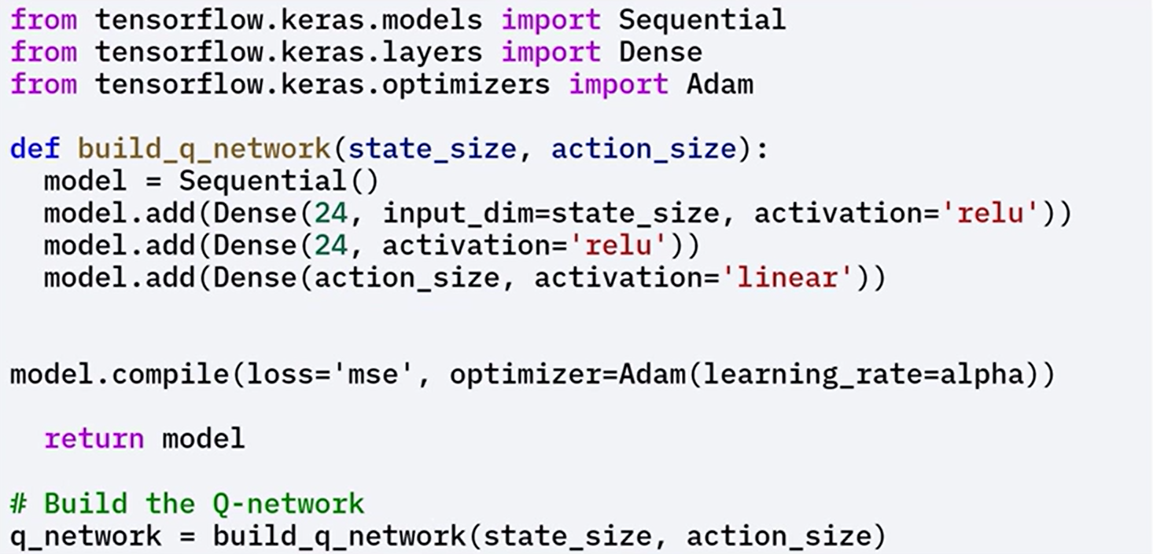

🔸 **Train the Q-network:**

Training involves several steps:

1. **Initialize the state**

Reset the environment to get the initial state, agent interacts with that state for a given number of steps.

1. **Select an action**

Use an **epsilon-greedy policy** to balance exploration and exploitation:

* + - **With probability ε**: choose a random action (exploration)
    - **With probability 1 – ε**: choose the action with the highest predicted Q-value (exploitation)

1. **Take the action**

Execute the selected action in the environment to receive the next state and reward

1. **Update the Q-values**

Use the **Bellman equation** to compute the target Q-value

Train the Q-network to **minimize the difference** between the predicted and target Q-values

1. **Repeat**

Continue the process until the agent reaches a **terminal state** or achieves the **goal**

Over multiple episodes, **gradually reduce** the exploration rate ε to shift from **exploration** to **exploitation**.

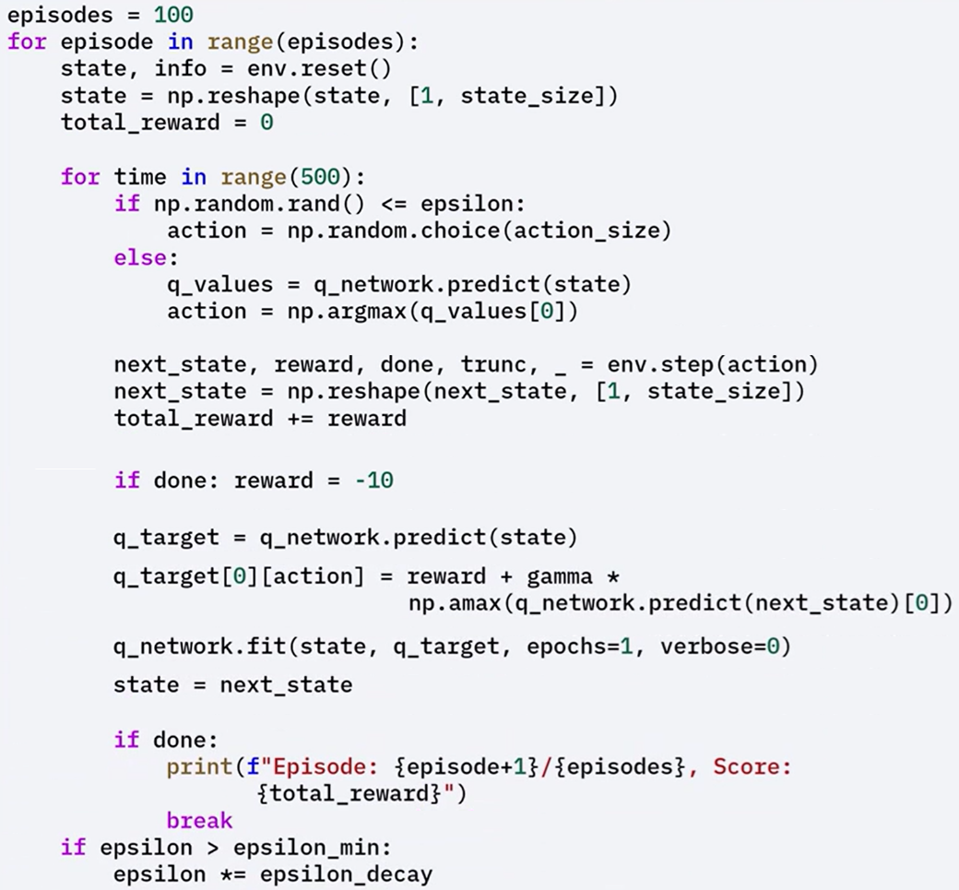

🔸 **Evaluate Trained Agent:**

After training is complete the agent is **evaluated** by letting it interact with the environment using the **learned policy**

During evaluation, the agent chooses actions based on the **maximum Q-values,** exploiting the learned Q-values to maximize rewards.

The agent's behavior is rendered, to measure performance based on the total rewards accumulated over several episodes.

The evaluation confirms whether the agent successfully learned an **effective policy** for solving the task.

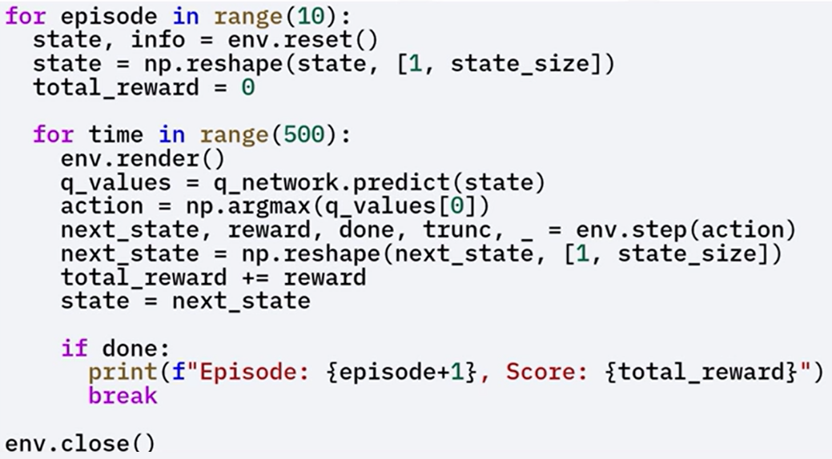

### ✅ Takeaways

✅ Reinforcement learning trains agents to make **sequential decisions** to maximize **cumulative reward**.

✅ Q-learning is a **value-based**, **off-policy** algorithm that estimates the Q-value function Q(s, a).

✅ The **Bellman equation** is used to iteratively update Q-values.

✅ For large state spaces, **Q-networks** implemented with **Keras** replace Q-tables.

✅ The **epsilon-greedy policy** balances exploration and exploitation during training.

✅ After training, the agent is evaluated based on **reward accumulation** over multiple episodes.

✅ The Q-network is trained using **Keras**, **Adam optimizer**, and **mean squared error loss** to approximate Q-values.

## 📌 Deep Q-Networks (DQNs) with Keras

DQNs leverage deep neural networks to approximate the Q-value function and enable reinforcement learning to scale in complex environments.

The key innovations (experience replay and target networks) help stabilize training and improve performance.

### 🔹 What are Deep Q-Networks

Deep Q-Networks (DQNs) extend the Q-learning algorithm by replacing the Q-table with a deep neural network that approximates the Q-value function.

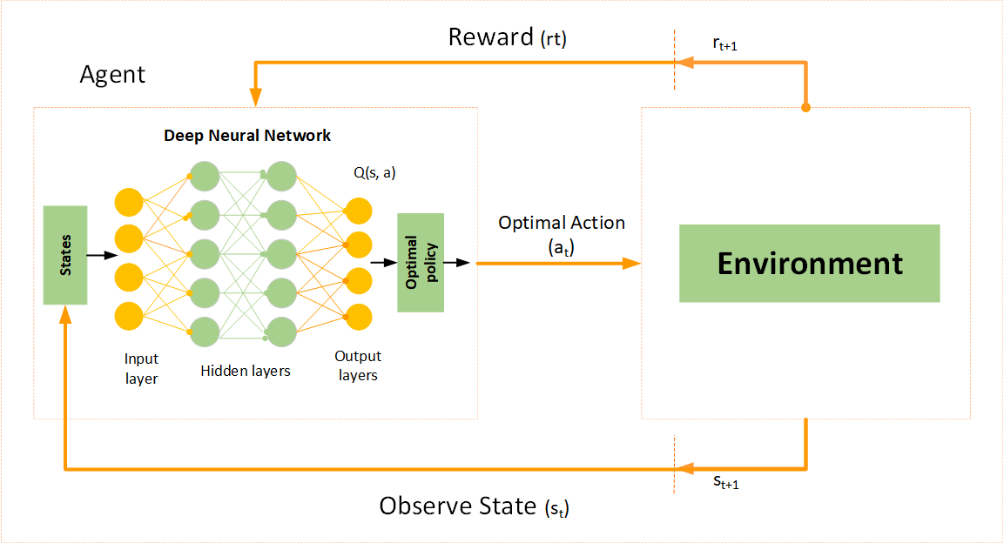

Traditional Q-learning becomes impractical in environments with large or continuous state spaces due to the exponential growth of the Q-table. DQNs solve this problem by allowing the agent to estimate Q-values through a neural network, enabling scalability in more complex settings.

The success of DQNs lies in stabilizing training using two techniques:

* **Experience replay**
* **Target networks**.

### 🔹 Key Concepts of DQNs

🧠 **Q-Value Function Approximation**:

Instead of explicitly storing all state-action pairs, DQNs use a neural network to approximate the function ***Q(s,a)***, where “**s**” represents the state and “**a**” represents the action.

This generalizes Q-values across a broader range of states.

🧠 **Experience Replay:**

The agent stores its experiences in the form of (*state, action, reward, next_state*) in a replay buffer.

During training, it samples random minibatches from this buffer. This technique breaks the correlation between consecutive experiences and stabilizes learning.

🧠 **Target Network:**

A secondary neural network, the target network, is introduced to generate more stable Q-value targets.

Unlike the primary Q-network, the target network is updated less frequently, reducing oscillations and divergence during training.

### 🔹 DQNs implementation steps

The process of implementing DQNs follows the structure of Q-learning but introduces new components to improve stability and scalability.

Each step is critical to correctly build and train a deep reinforcement learning agent.

🔸 **Initialize the environment and parameters:**

Define the learning environment (por example, using OpenAI's Gym platform).

Set all necessary hyperparameters for training, including learning rate, discount factor, exploration rate, and replay buffer size.

🔸 **Build the Q-Network and Target Network:**

Two neural networks are created using Keras: the **primary Q-network** and the **target network**.

Both share the same architecture, but the target network’s weights are updated less frequently to serve as a stable reference for computing Q-value target.

🔸 **Implement Experience Replay:**

A replay buffer is initialized to store agent experiences.

During training, random minibatches are sampled from the buffer to update the Q-network. This reduces the impact of correlated experiences and improves learning efficiency.

🔸 **Train the Q-Network:**

The Bellman equation is applied to iteratively update Q-values, leveraging outputs from the target network as stable references.

The primary Q-network is trained using gradients computed from the loss between predicted Q-values and target Q-values.

🔸 **Evaluate the Agent:**

After training, the agent interacts with the environment using the learned policy.

Its performance is measured based on cumulative rewards across multiple episode

### 🔹 DQNs Code Implementation Workflow with Keras

This section outlines the practical implementation of DQNs using the CartPole environment and Keras, including network architecture, training loops, and evaluation setup.

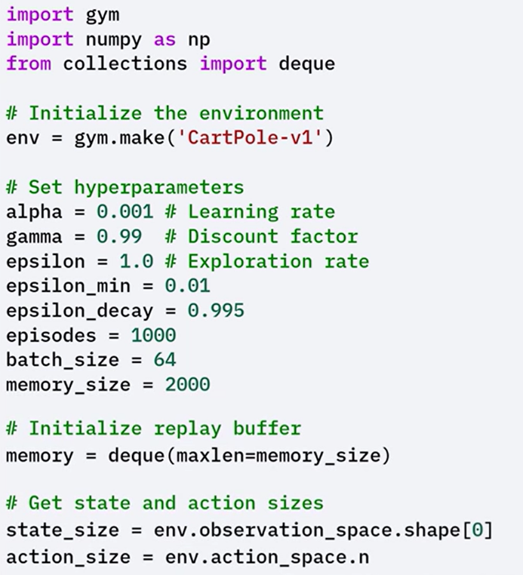🔸 **Environment and Hyperparameters Initialization**:

The **CartPole** environment is initialized using gym.make.

Key hyperparameters such as learning rate, discount factor, exploration rate (ε), and batch size for experience replay are defined.

🔸 **Replay Buffer Initialization:**

A double-ended queue with a fixed size is created to store the agent’s experiences (state, action, reward, next_state, done) over time.

Deque, is a data structure that allows efficient insertion and deletion of elements from both its front, head, and back, tail.

🔸 **Q-Network and Target Network Creation:**

Two identical networks are created, **primary Q-Network** and **target network.** These networks are used to predict Q-values and compute targets for training.

Both networks have the same architecture, with two hidden layers and ReLU activation.

The target network is periodically updated to match the weights of the primary Q-network. This delay helps prevent instability during learning.

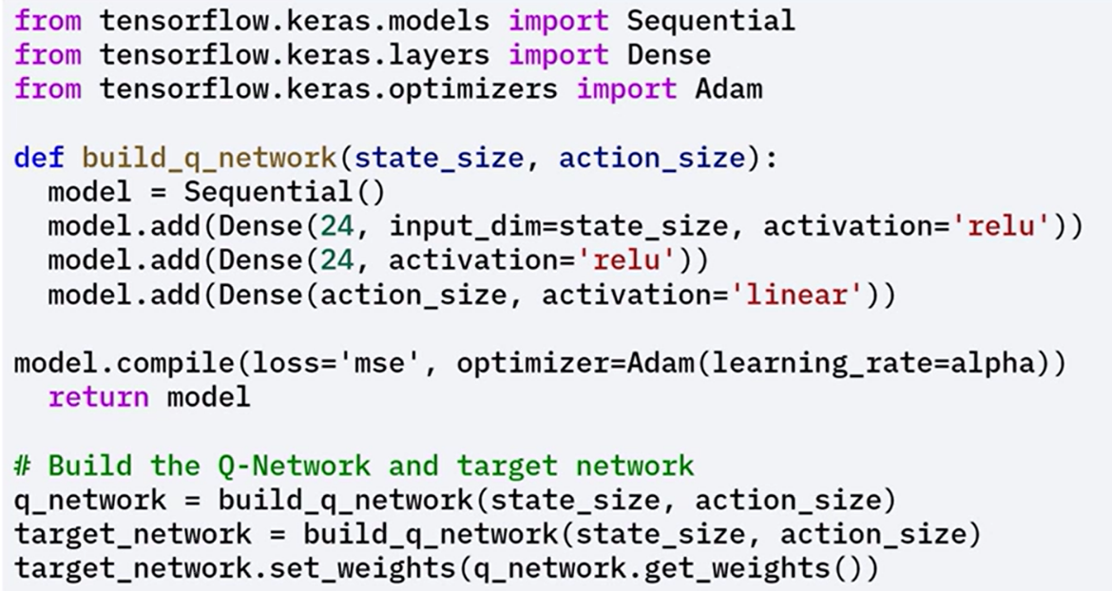

🔸 **Experience Storage and Sampling:**

A **remember()** function stores (state, action, reward, next_state, done) **tuples** in the replay buffer.

The **replay()** function samples minibatches randomly to break experience correlation between consecutives experiences and improve convergence.

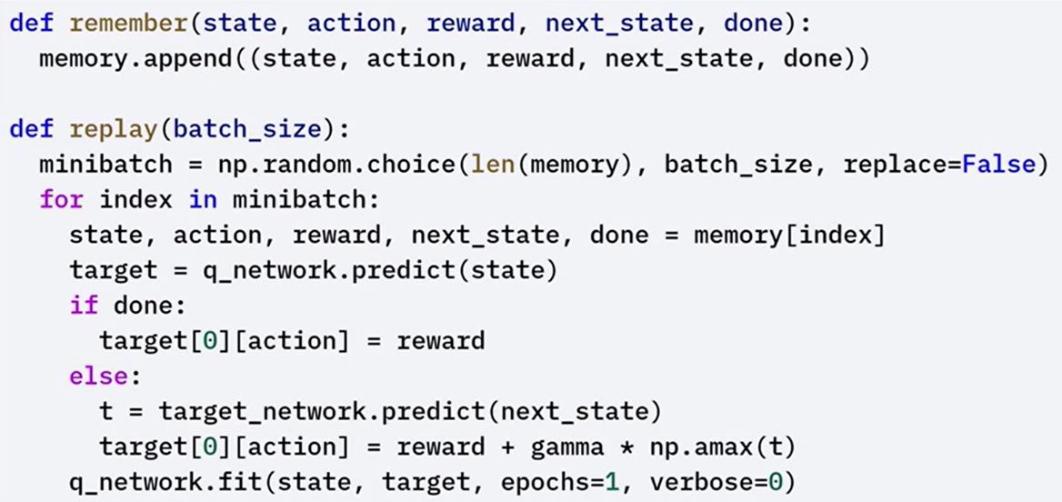

🔸 **Training Loop and Policy:**

The training loop runs for a defined number of episodes.

At each step, the agent selects actions using an ε-greedy policy (random action with probability ε, or greedy action otherwise).

After each episode, the ε value decays gradually to promote exploitation over exploration.

For each sampled experience, the Bellman equation is applied to compute the target Q-value. The Q-network is trained to minimize the difference between predicted and target values.

 Target networks weights are periodically updated to match the primary networks weights.

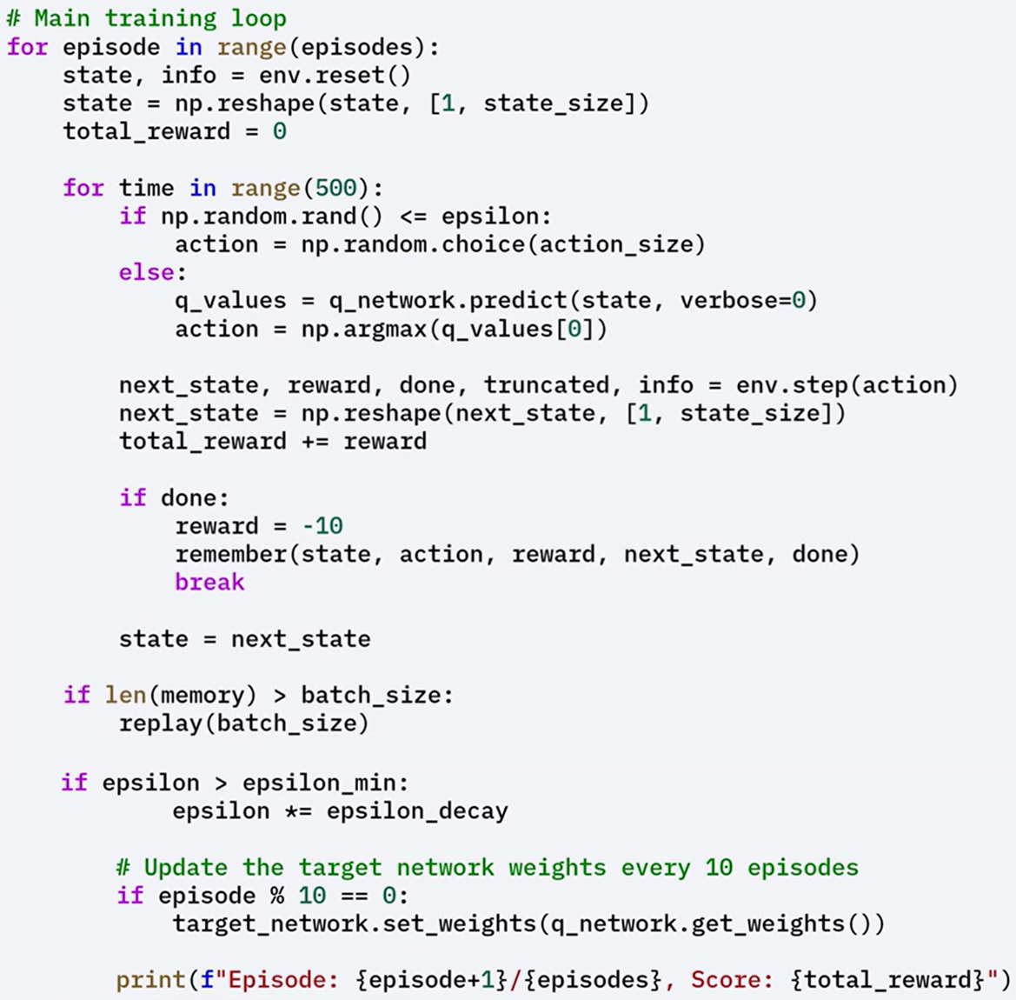

🔸 **Agent Evaluation:**

After training, the agent is evaluated by running episodes with the learned policy.

The environment is rendered for visual inspection, and total rewards are printed for each episode.

During this phase, the agent focuses on exploiting the learned Q-values.

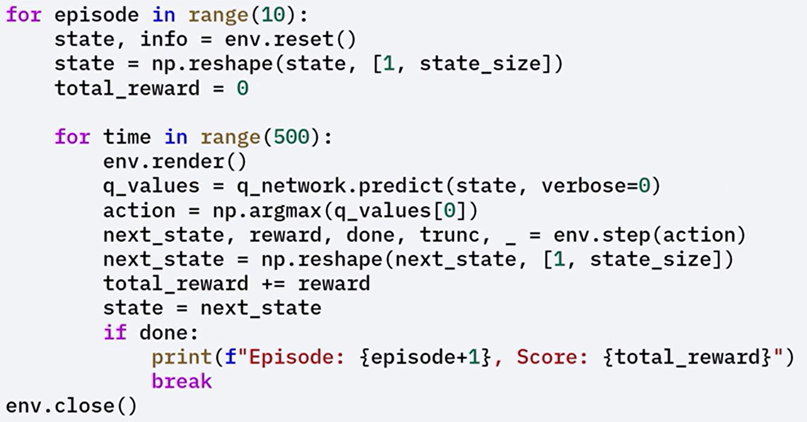

### ✅ Takeaways

✅ Deep Q-Networks (DQNs) extend Q-learning by using neural networks to approximate Q-values, enabling scalability to large or continuous state spaces.

✅ DQNs use experience replay and target networks to stabilize training and improve learning performance.

✅ The DQN implementation includes initializing the environment, defining networks, storing and sampling experience, training with the Bellman equation, synchronizing target networks, and evaluating the agent with the learned policy.